Group 3 Project Proposal

**Group Members**

Stefan Powell, Jack Davis, Christopher Fisher

**Topic**

Every four years the world’s attention turns to the Summer Olympics. The oldest event of the Olympics is running. Running is something that all humans can do, but only the fastest compete at the Olympics. Throughout the history of the sport people have continued to improve and perceived barriers have been surpassed. Previously a 10 second 100m, a 4 minute mile, and a 2 hour marathon were all considered impossible. The Olympics is a showcase of the top athletes of each generation, and our analysis will show what trends exist.

Our emphasis will be to see how the event’s results have changed throughout time. We hope to also better understand how the results from an Olympic race are distributed.

**Data sources**

The data that will be retrieved from the World Athletics Website. The following link shows the 2019 results.

<https://www.worldathletics.org/records/toplists/sprints/100-metres/outdoor/men/senior/2019?regionType=world&timing=electronic&windReading=regular&page=1&bestResultsOnly=true>

**Data description**

**Research questions**

1. How has the winning time of the Men’s 100m dash changed? What about the mean and last place of this event?
2. How has the winning time of the Men’s Marathon changed? What about the mean and last place of this event?
3. How do the distributions of the Men’s 100m dash and marathon compare?
4. How are the results of a typical Olympic track event distributed? Does it follow a normal distribution or do athletes tend to bunch up near the winner?
5. Does the distribution curves change over time for a specific event? What can we deduce from their changes?

**Data**

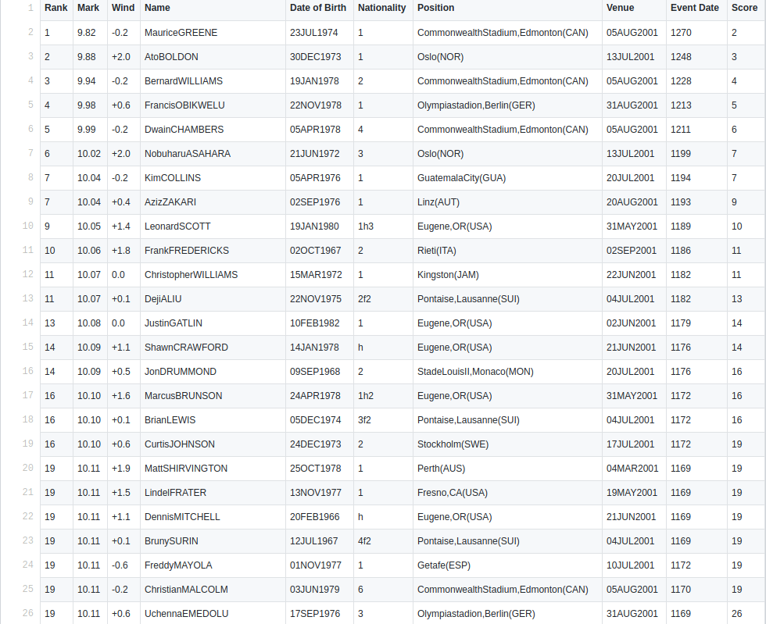

The data that will be needed for the Proposal will first have to be properly parsed for each event before it can be used. The image above shows partially parsed data.